Evidence Output

T016:

Valid postal code case.

Not input anything in postal code case.

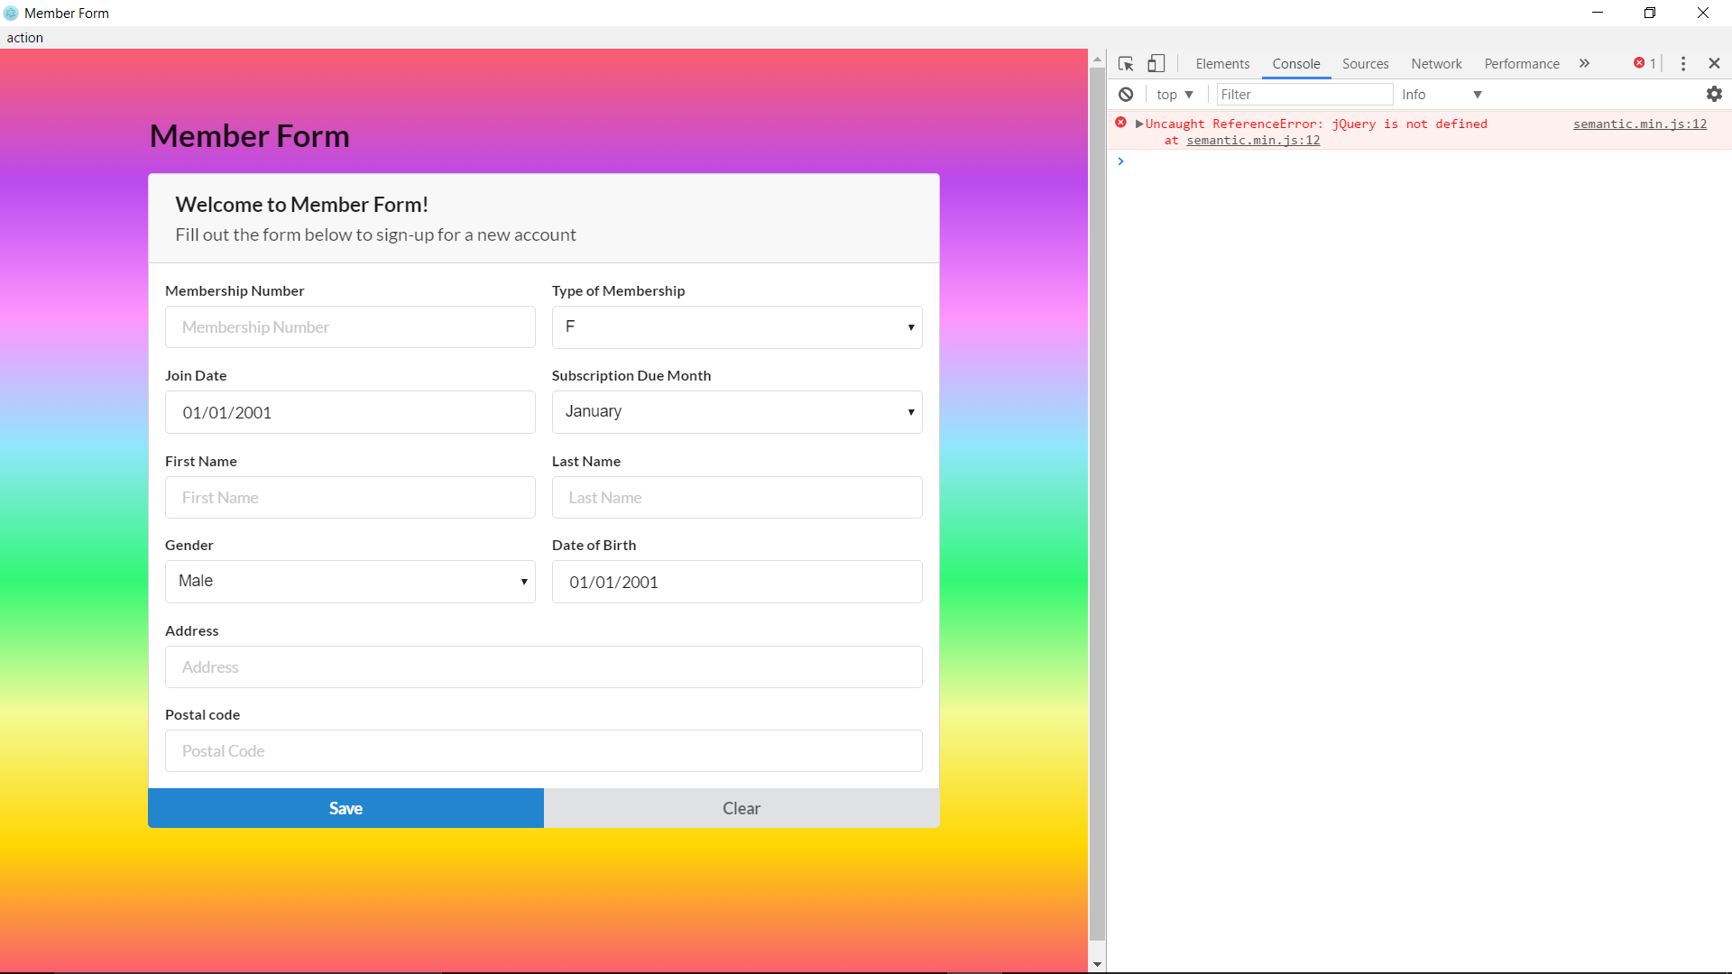

Valid postal code case fail.

